

INTRO TO CS

TASK 6

NAME: ESLAM YASSER FATHY AMINE

ID:  4221029



WEB PAGE

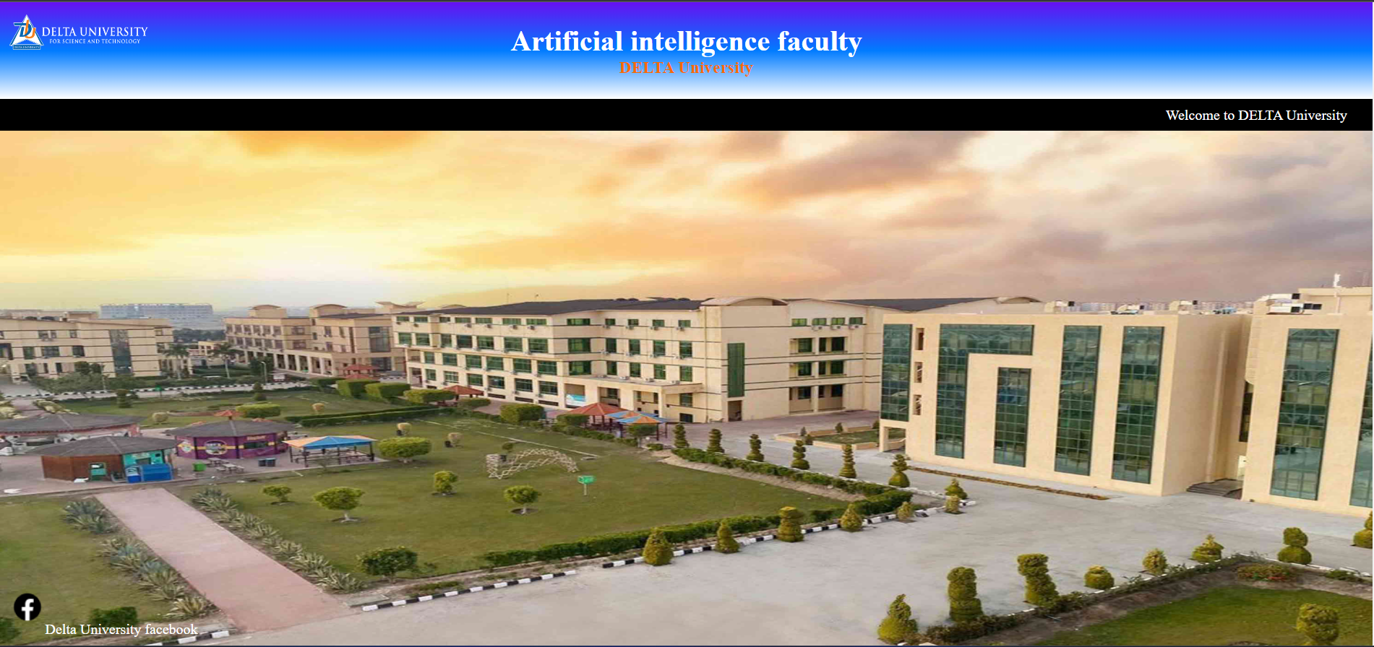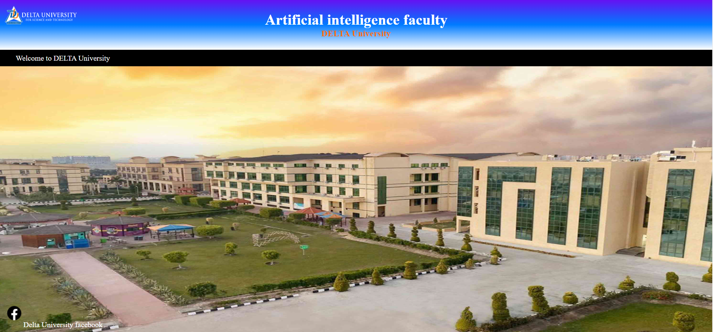

HTML

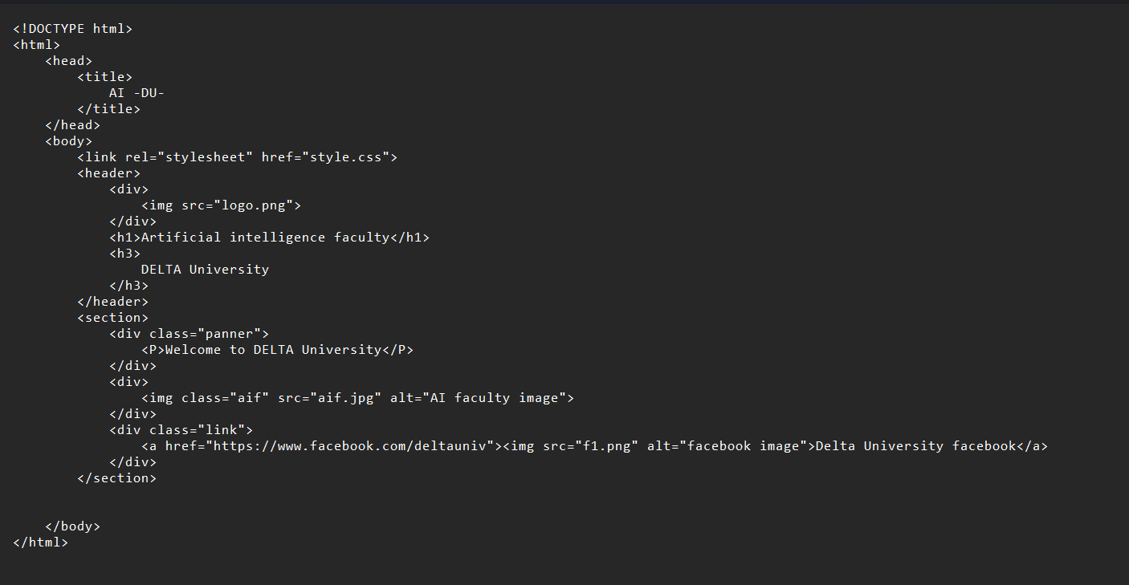

CSS

